Essential Piggery Equipment
- SS Pig Feeders
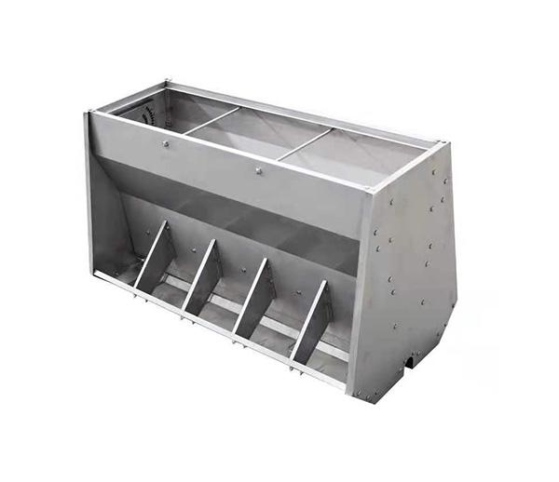

- Pig Waterers / Nipple Drinkers
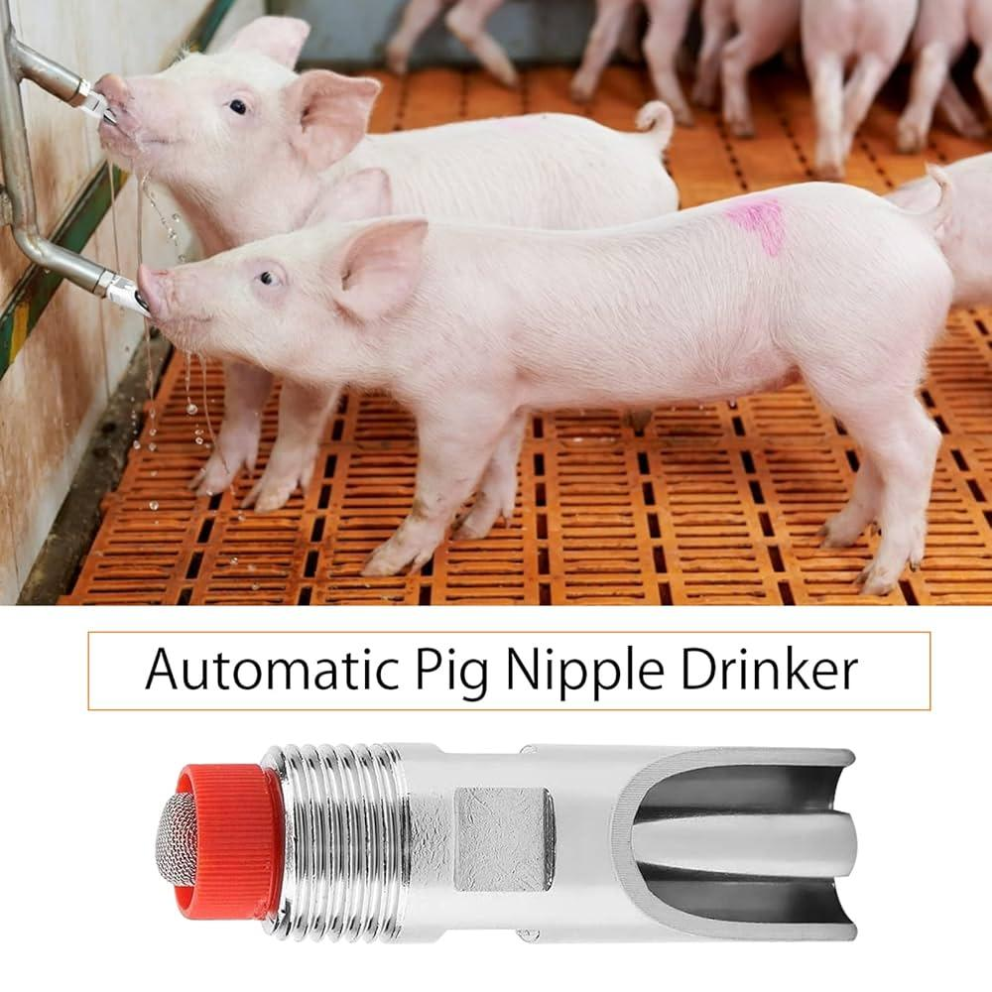

- Farrowing Crates
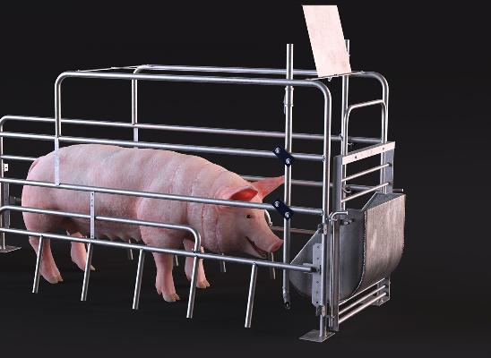

- Weighing Scale

